HTML FORMS
Html forms referred to the structure to collect the user’s input.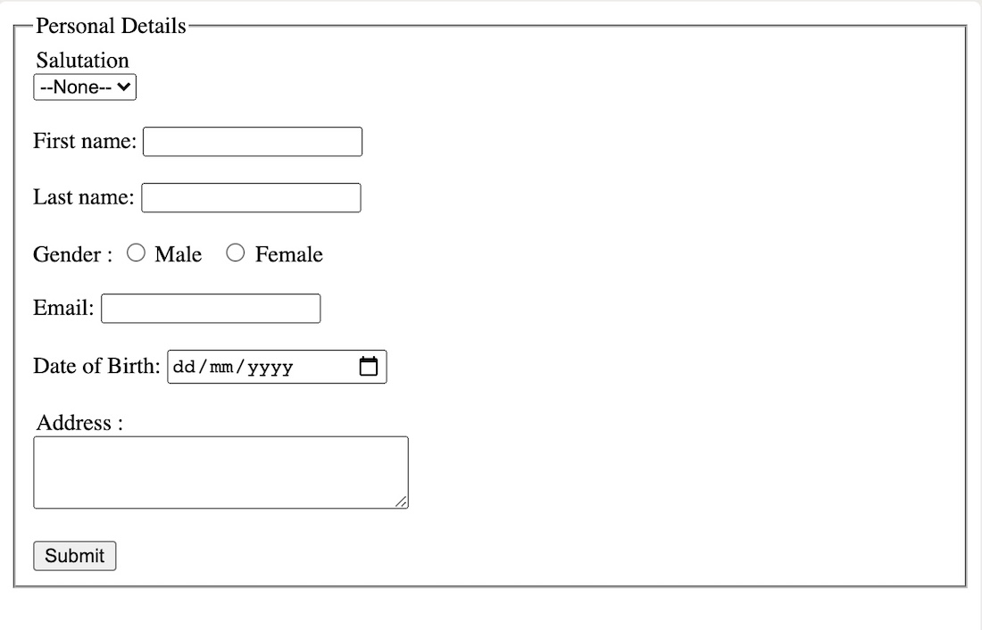
Form tag is used to create html form. <form>
Input tag is used to receive the input from users. <input>
Label tag is used show the variable name of a text field. <label>
Note:- The id attribute of the input tag and for attribute of label tag should be same.

Input tag contains various types:-
Type=”text” //creates the text field
Type=”radio” //creates the radio buttons [circle checkmarks].
Type=”checkbox” //creates the check boxes
Type=”date” //creates the calender input button.
Place holder are the faded texts used inside the text fields.
Fieldset and legend tags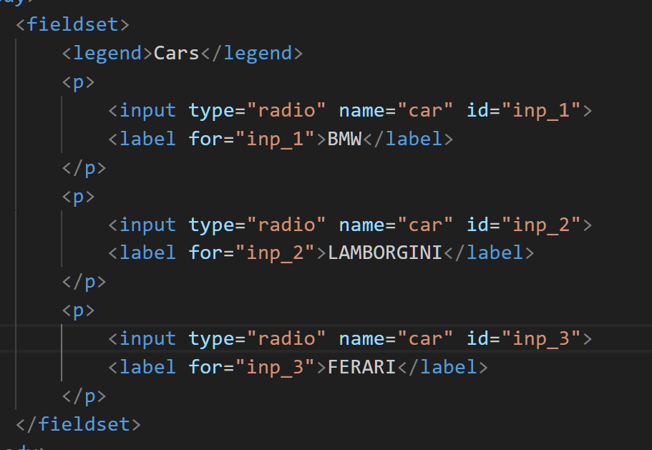

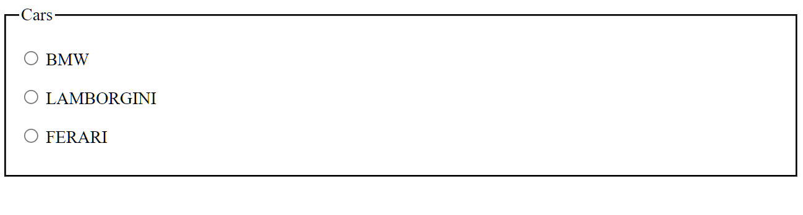
Here fieldset tag is used to declare a group of widgets and legend tag is used to declare the title of the specific field set.[cars]

Here,
Radio buttons are used as the input but it also contains name, id, values.
Name attribute specify that the same names are of same class and
Id attribute is used to specify the uniqueness of the textfield and used to link with the label. But id of input tag and for of label tag must be same.
Importance of div tags:-
Div tags are used to divide the html code into parts and make easier to apply css to the specific part by the help of class attribute.
Syntax:- <div class=”class_name”>
</div>
Steps to create a form:-
- To start with, make a local copy of our blank template file in a new directory on your computer.
- Next, create your form by adding a <form> element:
- Inside the <form> element, add a heading and paragraph to inform users how required fields are marked:
- Next use the concept of form to complete the section of forms
For example,
Select index.html from the current repository.

Importance of select tag:-
<label for="cars">Choose a car:</label>
<select name="cars" id="cars">
<option value="volvo">Volvo</option>
<option value="saab">Saab</option>
<option value="mercedes">Mercedes</option>
<option value="audi">Audi</option>
</select>

Input type number syntax
<label for="quantity">Quantity (between 1 and 5):</label>
<input type="number" id="quantity" name="quantity" min="1" max="5">

<label for="quantity">Quantity (between 1 and 5):</label>
<input type="number" id="quantity" name="quantity" min="1" max="5">

Questions and answer

<details>
<summary>What is your name</summary>
Durga Mishra.
</details>

